Group 7 Project 1 Calvin Thang

Learning how to create diagrams in a database as a navigation tool. Creating diagram views as subject areas that isolates various sub-systems for querying information. Using the subject areas to solve problems for the business and document the necessary information needed to provide the appropriate query resolution. Writing 20 queries by each group member across the five databases identified.

Developing the soft skills needed in the business work environment such as teamwork, documentation and creating workflows.

Learning the structure of a newly acquired database systems by your company without any documentation.

Each Problem should follow the format in Problem 01.

Contents

Create a diagram and two subject area diagrams of sub-systems based upon the 5 databases described in Problem 1 2

Show the diagrams in standard and key view 2

Example of the orders sub-system in NORTHWINDS2019TSQLV5 3

Detailed explanation of the problem that will help the developer to write the query to resolve the issue 3

Database 4

Diagram(s) of tables 4

Columns from Standard view 5

Project following columns from their respective tables in the select clause 5

Order by 6

Problem solving Query 6

Sample Relational Output with total number of rows returned (2155) 6

Sample JSON Output with total number of rows returned (2155) 7

Proposition 02: Your question using Database Name? 8

Proposition 03 to 20: Your question using Database Name? 8

# Create a diagram and two subject area diagrams of sub-systems based upon the 3 databases described in Propostion 1

## Show the diagrams in standard and key view

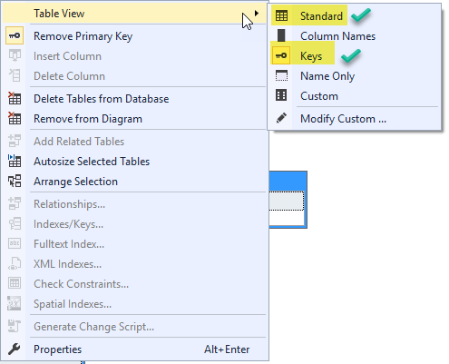

How create the different table views in the diagram editor.

## Example of the orders sub-system in NORTHWINDS2019TSQLV5

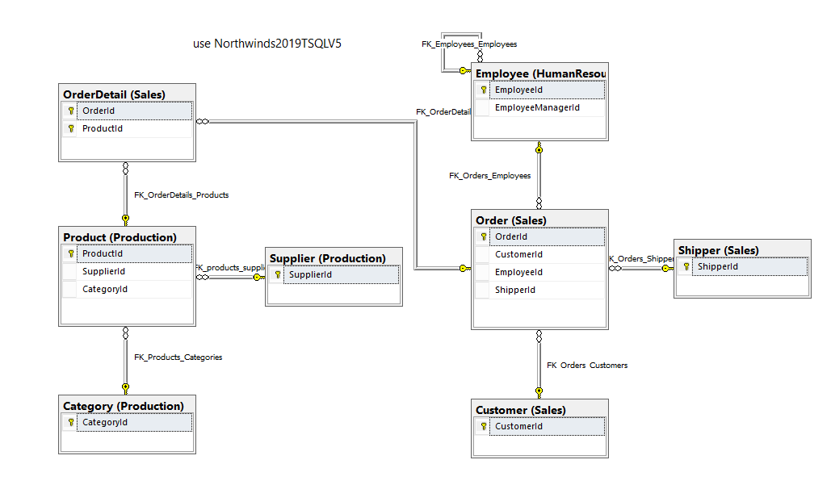 Proposition 01: Find by customer, the total cost and the total cost after discount for each product on the order using NORTHWINDS2019TSQLV5?

## Detailed explanation of the problem that will help the developer to write the query to resolve the issue

You should supply your specification of the problem statement.

## Databases

1. use Northwinds2020TSQLV6
2. use AdventureWorksDW2019
3. use AdventureWorks2019
4. use ContosoRetailDW

## Diagram(s) of tables

Foreign Key(s) or column(s) used for the join

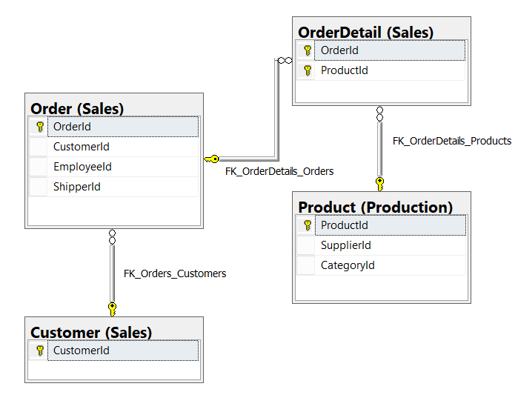

## 

## Columns from Standard view

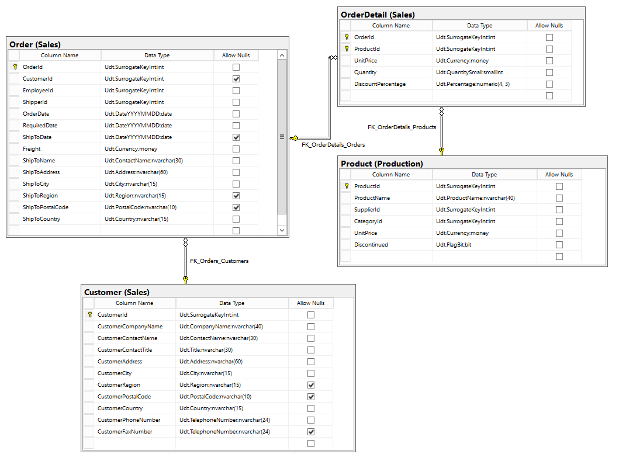

## Project following columns from their respective tables in the select clause

|  |  |
| --- | --- |
| Table Name | Column Name |
| Customers | CustomerCompanyName |
| Orders | OrderId  OrderDate |
| Products | ProductName |
| OrderDetails | OrderId  UnitPrice  Quantity  DiscountPercentage |
| DerivedColumn | TotalCost  TotalDiscountedCost (total cost after DiscountPercentage) |

## Order by

|  |  |  |
| --- | --- | --- |
| Table Name | Column Name | Sort Order |
| Customers | CustomerCompanyName | ASC |
| Orders | OrderDate | ASC |

## Problem solving Query

**All queries must use the ANSI 92 standard for queries with the type safe “on”.**

**-- Proposition 1: Find names of Employee whose territory is in France and StateProvinceName starts with G in AdventureWorksDW2019**

**USE AdventureWorksDW2019;**

**SELECT DISTINCT e.EmployeeKey**

**,e.FirstName**

**,e.LastName**

**,g.StateProvinceName**

**,g.EnglishCountryRegionName AS Country**

**FROM dbo.DimEmployee AS e**

**INNER JOIN dbo.DimGeography AS g ON g.SalesTerritoryKey = e.SalesTerritoryKey**

**WHERE g.EnglishCountryRegionName = 'France'**

**AND g.StateProvinceName LIKE 'G%';**

## Sample Relational Output with total number of rows returned (2155)

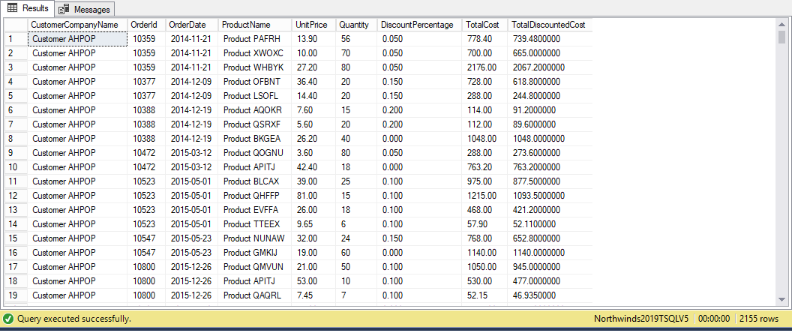

## Sample JSON Output with total number of rows returned (2155)

use Northwinds2019TSQLV5;

go

select c.CustomerCompanyName

, o.OrderId

, o.OrderDate

, p.ProductName

, od.UnitPrice

, od.Quantity

, od.DiscountPercentage

, TotalCost = (od.UnitPrice * od.Quantity)

, TotalDiscountedCost = (od.UnitPrice * od.Quantity) * (1 - od.DiscountPercentage)

from Sales.Customer as c

inner join Sales.[Order] as o

on o.CustomerId = c.CustomerId

inner join Sales.OrderDetail as od

on od.OrderId = o.OrderId

inner join Production.Product as p

on p.ProductId = od.ProductId

order by c.CustomerCompanyName

, o.OrderDate

for json path, root('CustomerOrders'), include_null_values;

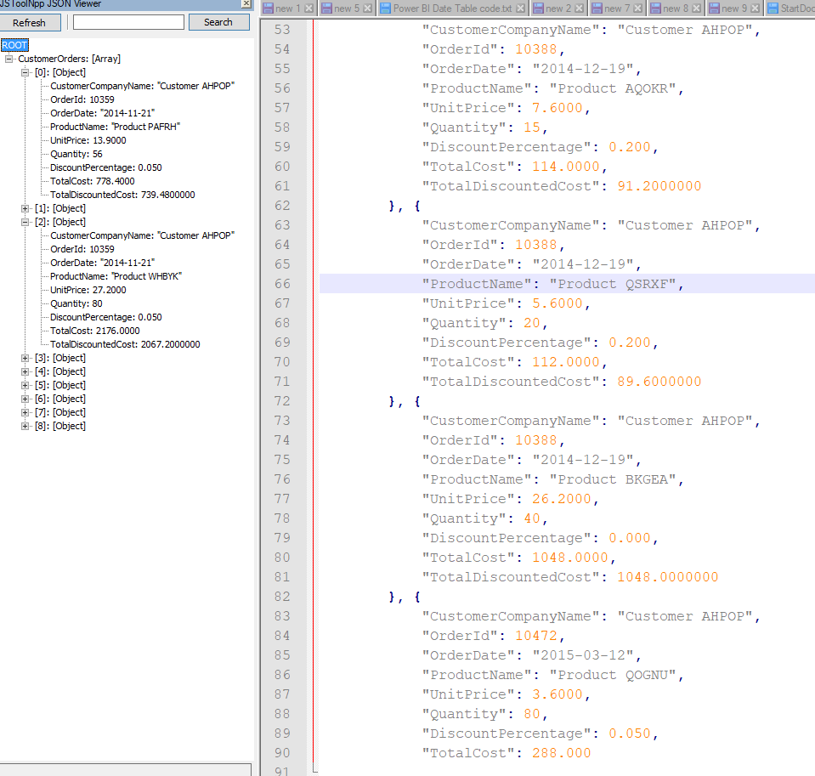

# Proposition 02: Your question using Database Name?

# Proposition 03 to 20: Your question using Database Name?